If I were Bruce almighty, and by devine intervention could sprout the perfect road bike from my rear, this is it, Please see my review at www.roadbikereview.com. The Madone has been impeccably cared for and has it's own rack in the house This Trek Madone 5.9 62cm has been ridden exactly 686 miles and it's being sold because of a spine injury. My big loss is your gain! The retail is $5800!!! There is not a mark on the frame anywhere, my shoes never even rubbed the cranks. You will be hard pressed to tell this bike from brand new. I will also include the original invoice, I've never registered the bike with Trek, so it could be registered by you to obtain the lifetime frame warranty.
FRAMESET: 62 cm
FRAME: OCLV 110 Carbon In pristine condition.
FORK: Bontrager Race XXX Lite, OCLV 110 Carbon w/extra long steerer left intact, see photos
WHEELS:
WHEELS: Bontrager Race X Lite Aero w/ DT swiss hubs, perfect condition, never a flat, true and round
TIRES: Michelin Pro Race 2, 700x23c, Michelin A1 tubes
DRIVETRAIN:
SHIFTERS: Shimano Dura-Ace STI, dual control
FRONT DERAILLEUR: Shimano Dura-Ace
REAR DERAILLEUR: Shimano Dura-Ace
CRANKSET: Dura-Ace 180mm (53-39)
CASSETTE: Shimano Dura-Ace 12-27, 10 speed
CHAIN: Dura-Ace 7800
PEDALS: Dura Ace, 7800's, the Lance pedal
COMPONENTS:
SADDLE: Koobi Xenon
SEATPOST: Bontrager XXX Race Lite, carbon
HANDLEBARS: Bontrager Race X Lite, Cinelli gel Tape, 42cm
STEM: Bontrager Race XXX Lite, 110mm
HEADSET: Chris King, you don't see this often.
BRAKESET: Shimano Dura-Ace w/STI levers
I don't need to sell this bike to you - it sells itself.
I have excellent feedback so bid with confidence. If you have any questions at all please email me. This bike is available for pickup in Greenville, SC, otherwise it can be shipped anywhere in the US via Fed-EX ground for $55. The frame alone is worth $3200 and the components are worth another $2700 - (the wheels are $800). I accept PayPal, if you use e-check then I must wait until the funds clear before I can ship the bike. I also accept cashier's check or money order but must wait until it clears with my bank before it ships. Email me with questions!
This is my personal bike, it has never been crashed and is in Mint Condition. It's been kept indoors in a protected environment (NOT in my basement!!).
They say a picture is worth a thousand words, so I've added plenty, so let them load and see for yourself, good luck and thanks
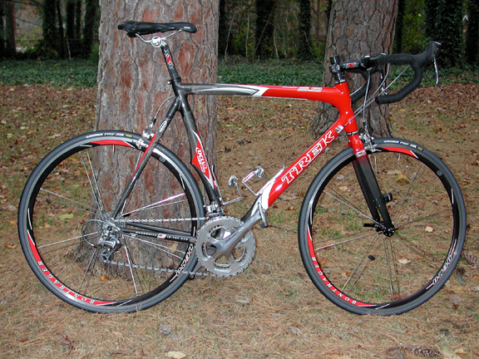

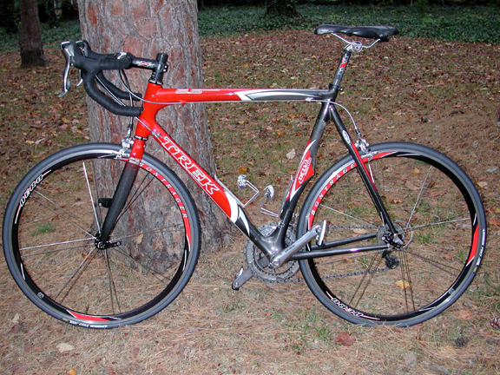

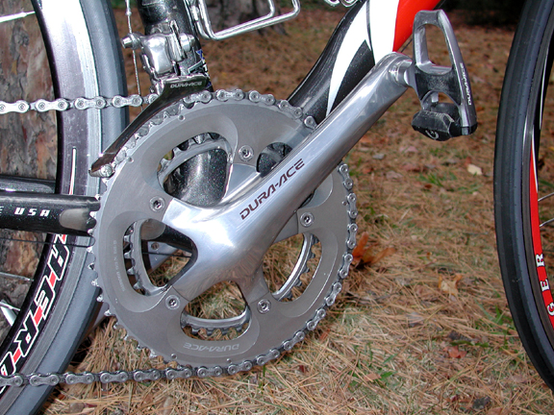

I've been asked if the Madone 5.9 is 110 Carbon, here is a photo of the seat tube
The Madone 5.9 line all use 110, except for the SSL which uses 55

I've been informed by TREK that the warranty will not carry over even though I have not registered the frame. I am unable to remove the line of text from the discription above. I'm sorry if this was misleading, for this was not my intension to promote what I can not deliver. thank you

On Dec-03-05 at 15:22:06 PST, seller added the following information:

The original Madone, that was designed for Lance to use in the mountain stages of the tour, is this frame. Then Trek got cute and confused everybody by naming all their road frames Madone. The SL was originally the 5900, and the new creation for those with unlimited gold cards, the SSL which uses 55 carbon.

On Dec-03-05 at 16:16:27 PST, seller added the following information:

The Madone 5.9 also differs from the SL and SSL in that the Madone 5.9 uses Aero tubes and stays proven by Trek development to take 2 min off of a 100k race. The SL and SSL use conventional bicycle design. The SL and SSL did take the top tube and head tube design from the Madone 5.9 in 2005 because of it's amazing handling. The Madone 5.9 was designed so that all watts make it to the rear wheel

